Electronic Catalog: Frequently Asked Questions

1. **Who do I contact if I find an error in the catalog?**
   1. Please contact [registrar@park.edu](mailto:registrar@park.edu). The system administrator will verify and correct as needed.
2. **Will there be paper copies of the catalog created?**
   1. No. However, you can print the pdf if desired.
3. **Will the catalog be downloadable?**
   1. The entire catalog can be printed via the pdf. Or, you can print specific sections such as the degree planners. You can click on the print icon and print any given page.
4. **Where can I find the pdf of the catalog?**
   1. Go to the right side menu and click on *What’s New*. The pdf is located on this page.
5. **Will the pdf be updated as changes occur?**
   1. No. The pdf is printed one time.
6. **How will I know when an item changes and will there be addendums?**
   1. Addendums will not be generated. Each time the catalog changes (after official start date) the changes will be noted in the *What’s New* section. Click on the right menu and select *What’s New* to view the page.
      1. The Registrar’s Office can provide an official letter if required by state authorizing agency or VA. Send a pdf print out of the page and the What’s New page to [registrar@park.edu](mailto:registrar@park.edu) and ask for an official letter noting the catalog change.
7. **How often will the catalog be updated with changes?**
   1. The catalog is updated as needed for changes to programs offered at campus locations, corrections or changes required for legal or accreditation purposes. All updates will be noted in the *What’s New* page. Changes will be live immediately.
8. **Will older catalogs be available in the system?**
   1. Starting with the 2018 catalog, final catalogs for each academic year are archived on the e-catalog website. Use the drop down menu to select the appropriate catalogs.
      1. *2021 catalog combined graduate and undergraduate catalogs
      2. Prior catalog years can be found by clicking on the right menu and selecting *Prior Year Catalogs* or by going to MyPark-Registrar page.
9. **How can I determine what locations a program is offered?**
   1. There are 2 main ways to identify which programs are offered at which locations.
      1. On the right side menu click on *Campus Locations and Programs.* Select the state and campus location to view all programs offered
      2. Click on *Programs by Degree Type* and select the desired program. Click on “[program name] Locations link to view all locations.



1. **How can I find the liberal education or writing intensive or professional writing courses?**
   1. There are 2 ways to identify liberal education or writing intensive courses.
      1. On the right side menu click on *Courses*. Under Course Search select desired area to view courses that fall under the area.

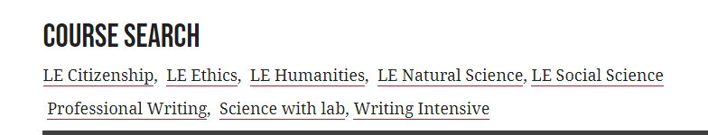

* + 1. Click on any course number throughout the course. If the course falls in a specific area, it will be listed under Fulfills area.

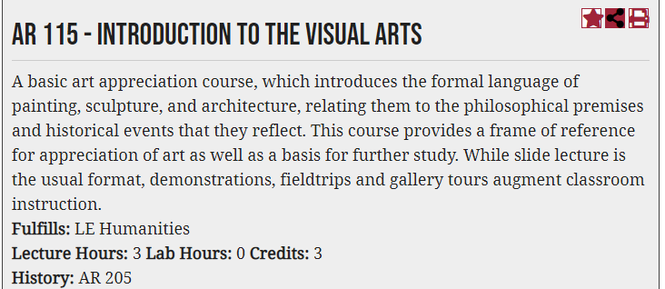

1. **How do I search for prerequites?**
   1. Click on the course number to display the full course description. The description will show all pre and corequisites.
2. **Will degree planners be specific to a catalog year?**
   1. Yes, degree planners are specific to the degree requirement noted in each catalog year. The degree planners change as the degree requirements change.
3. **Will previous names of courses or previous course numbers be listed in the catalog?**
   1. Yes, historical data will be noted in the course description